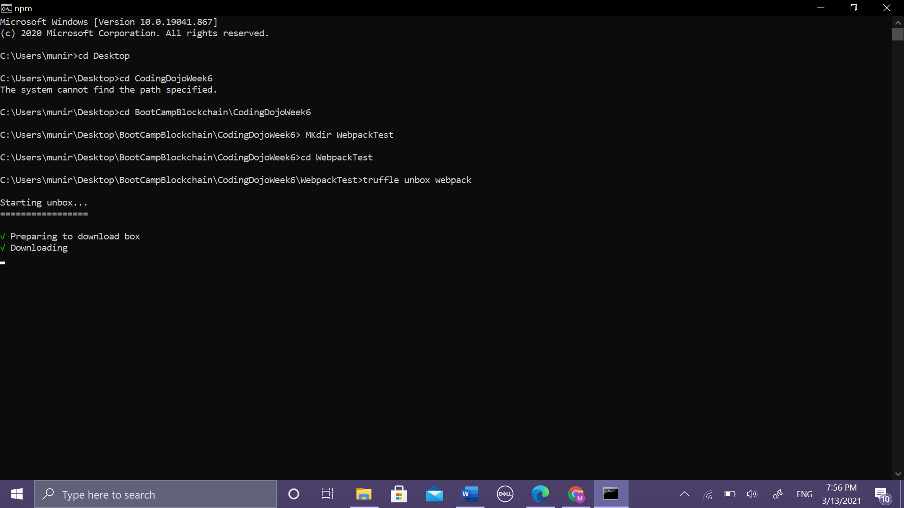

Figure 1/ first mkdir webpackTest then write "**truffle unbox webpack**"

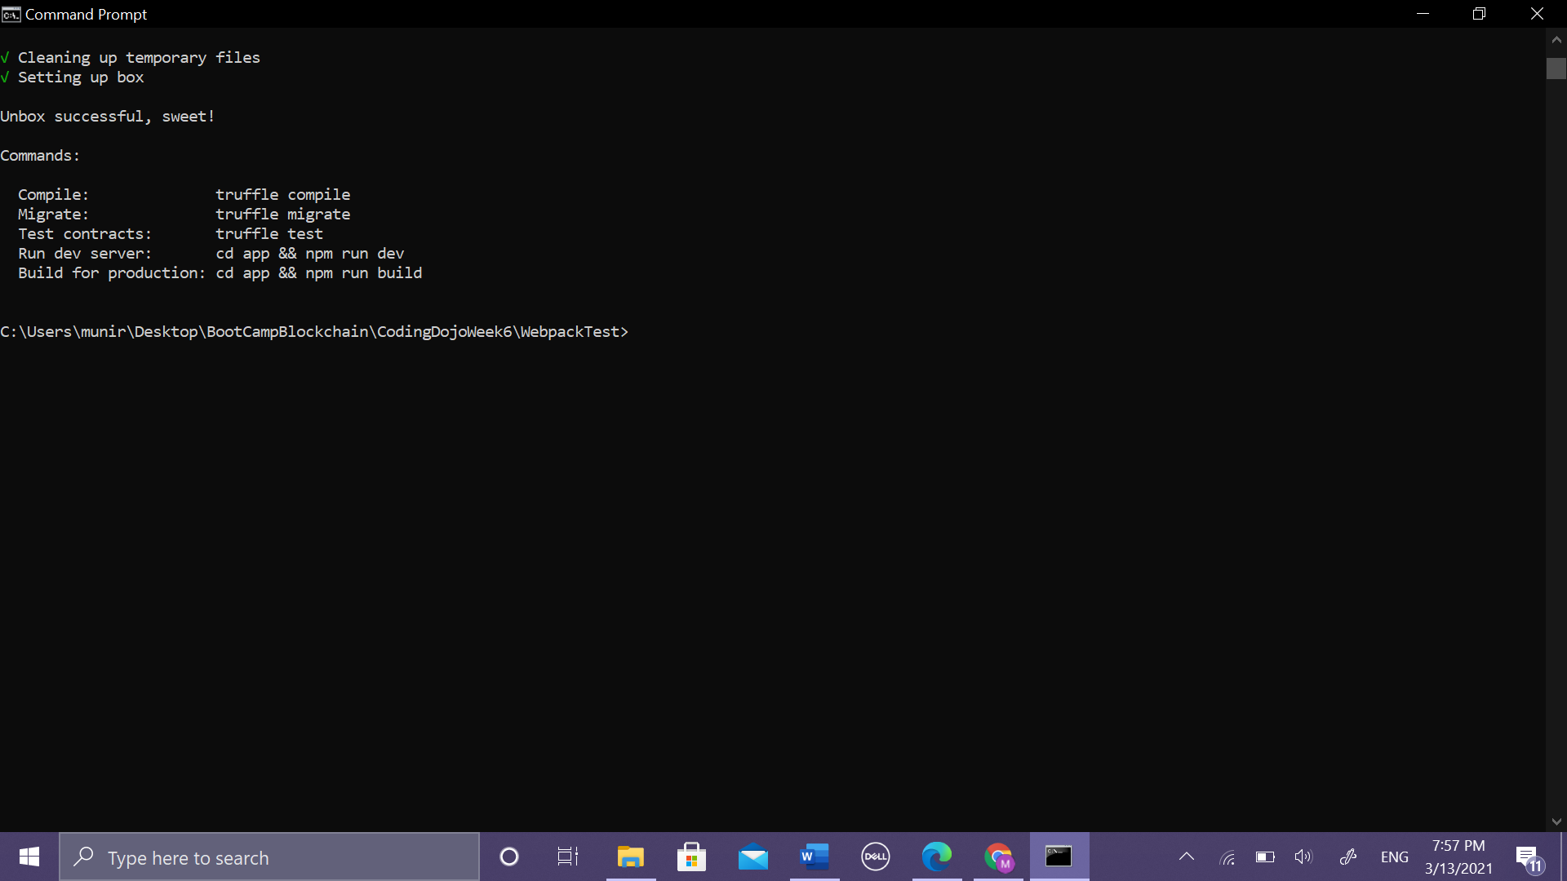

Figure 2/ ubox successfuly ✔

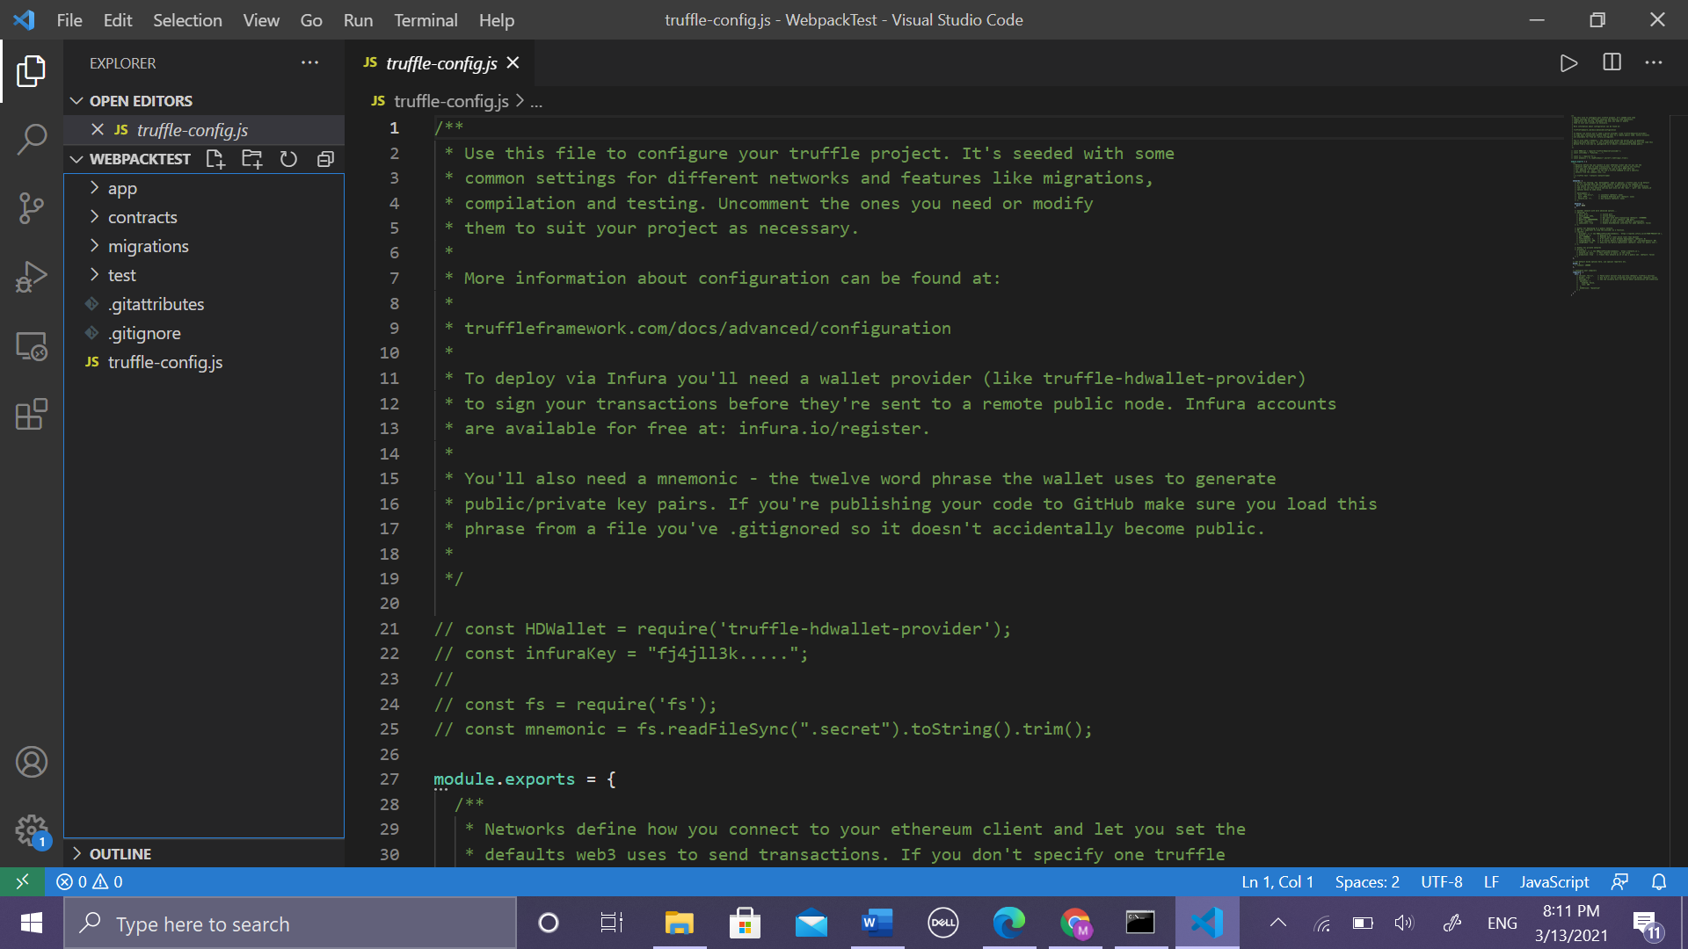

Figure 3/ open folder**"webpackTest"** on VS

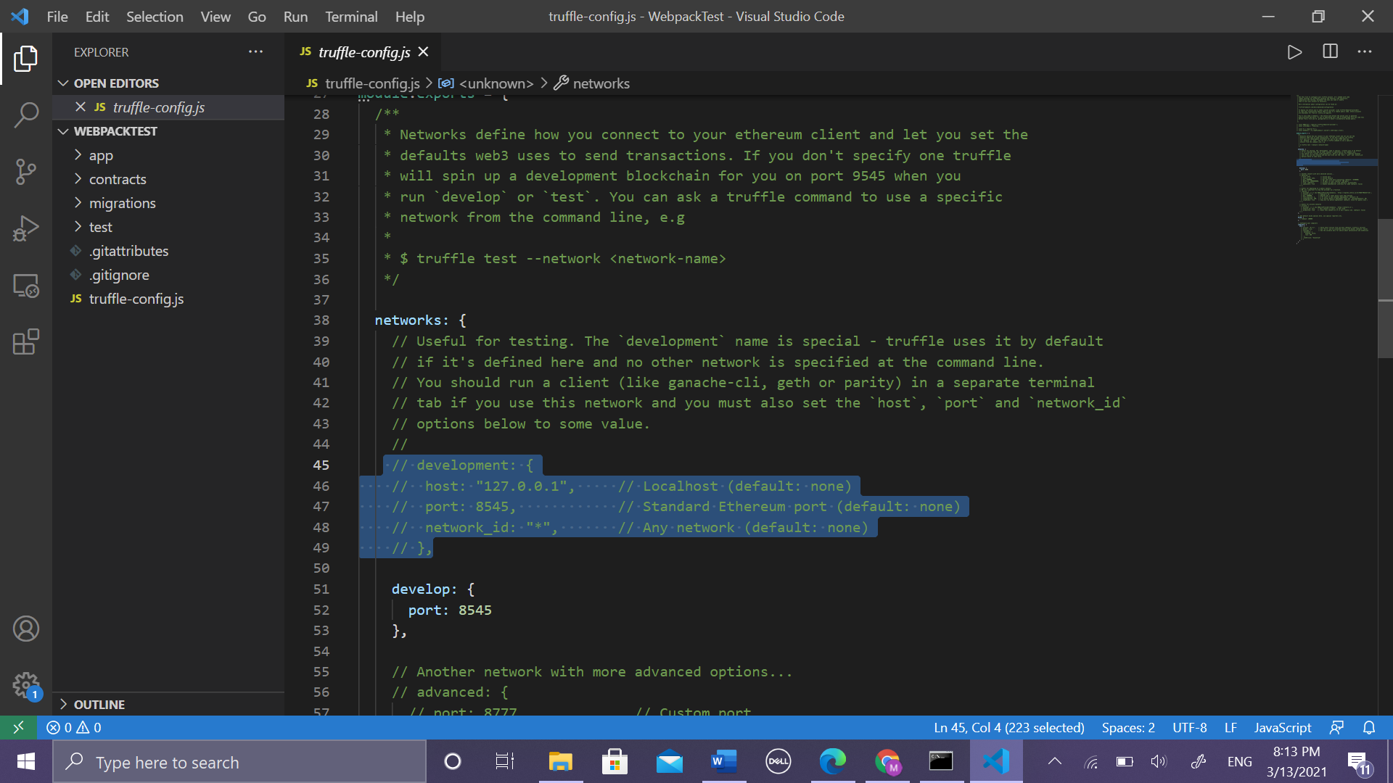

Figure 4/ remove the comment for this lines

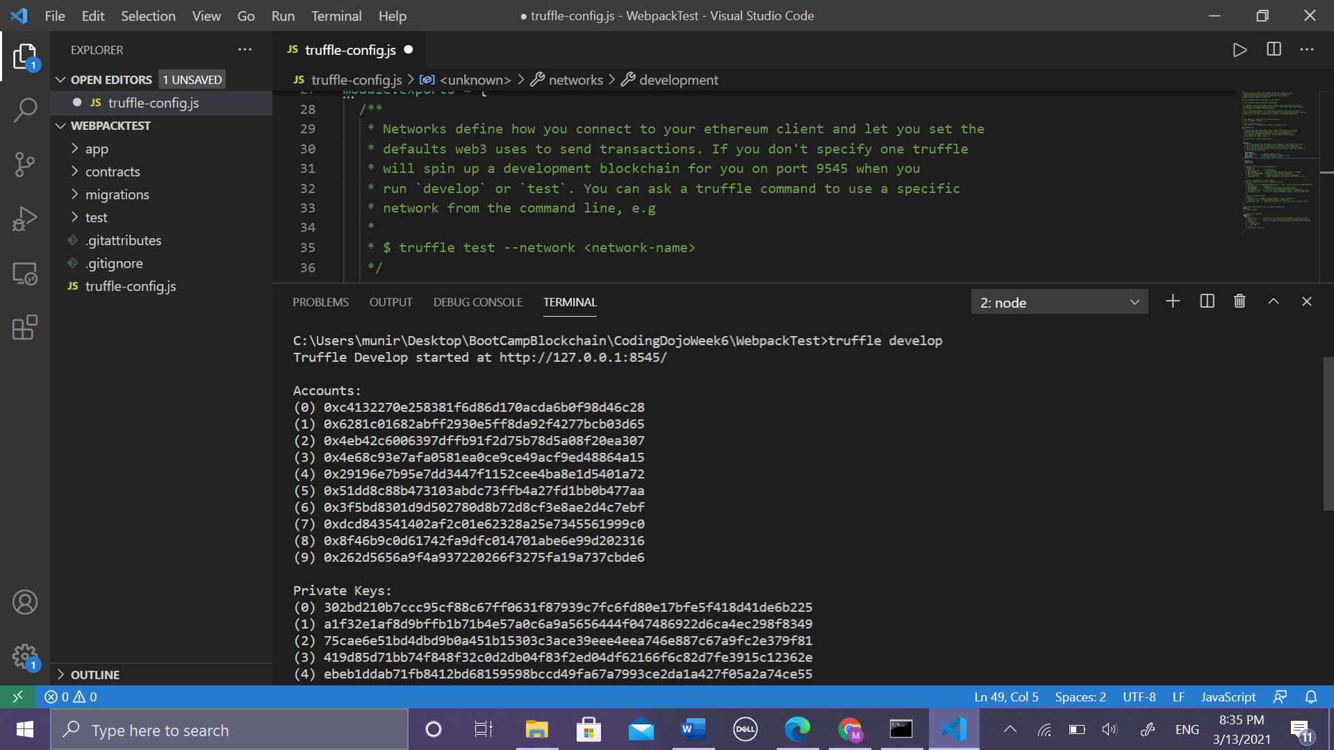

Use first private key to import on metamask

Figure 5/ write "**truffle develop**" to work on truffle network

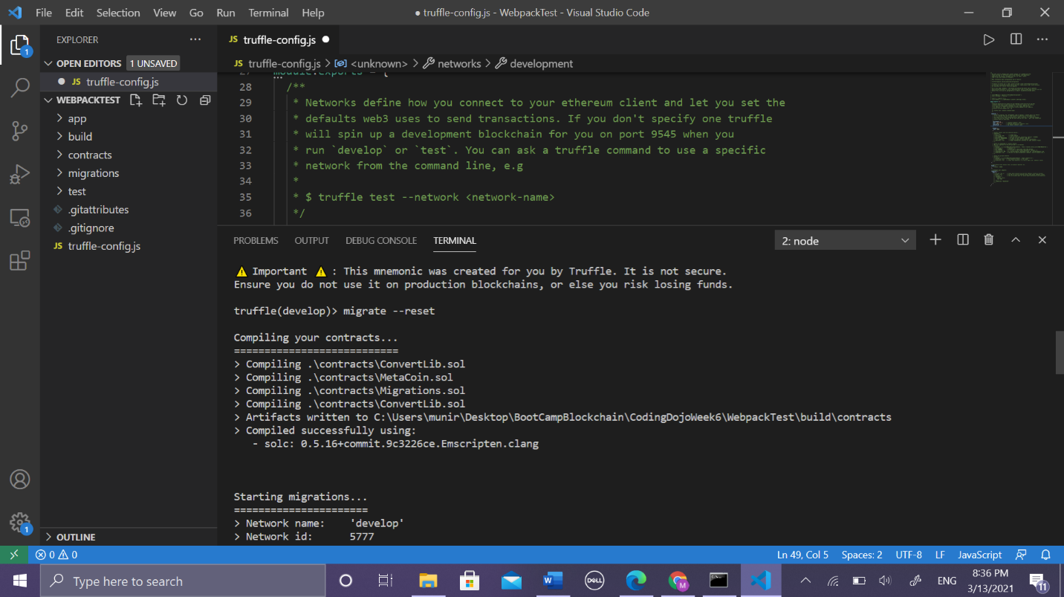

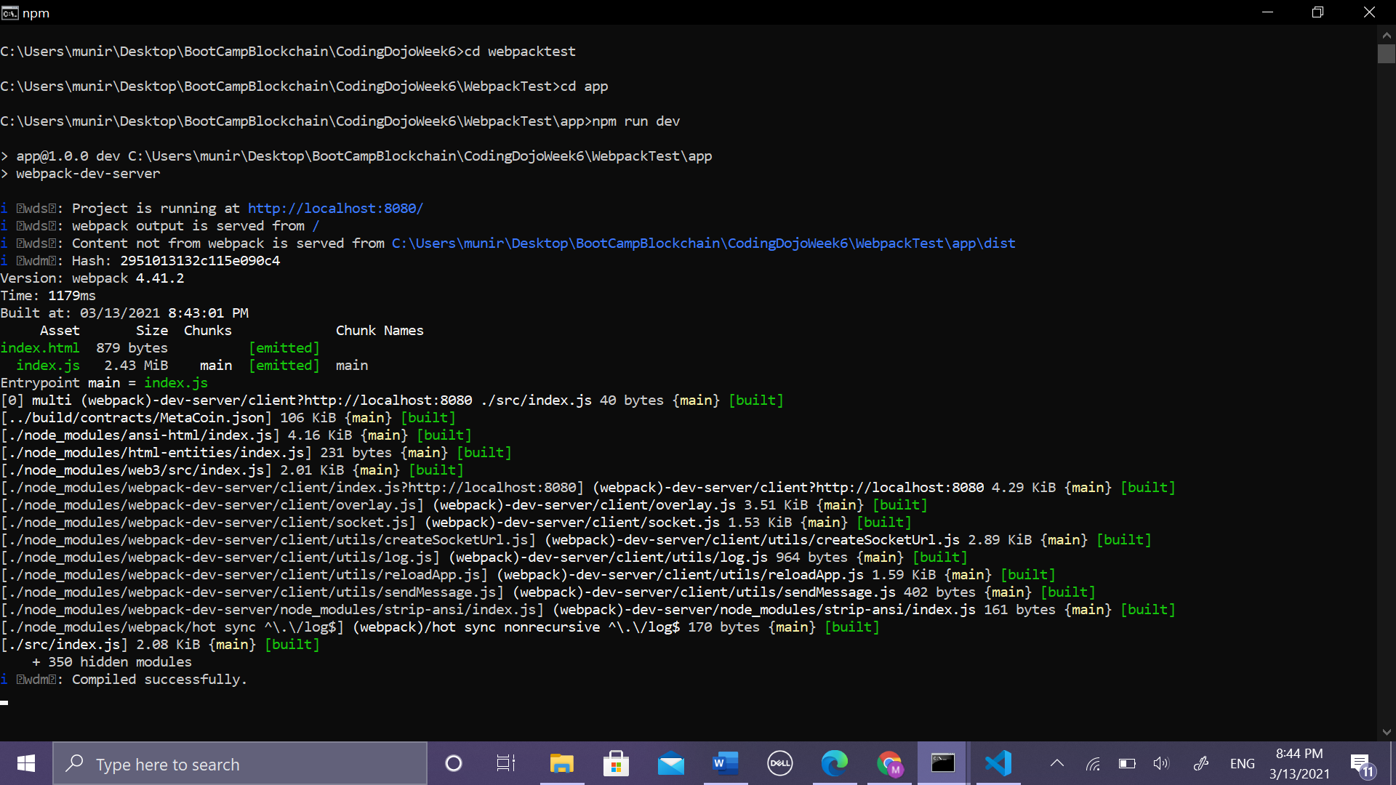

Figure 6/ on cmd inside app folder write "**npm run dev**"

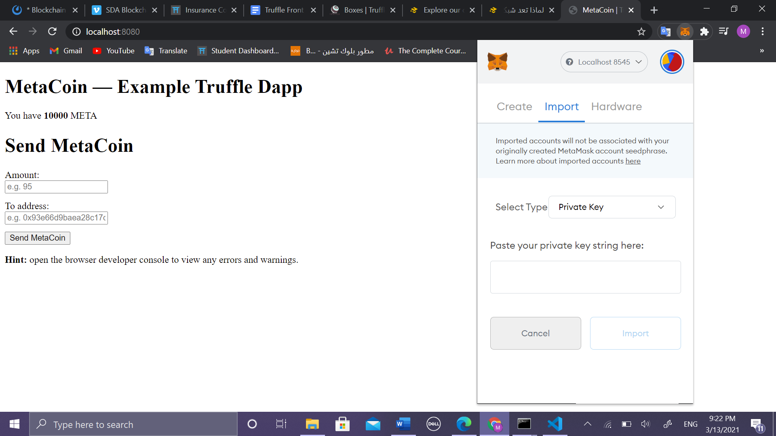

Figure 7/ open the url and this page will appear should be connected to metamask by click on import button then copy the first private key see **Figure5** and paste after that click on Import , then will connected

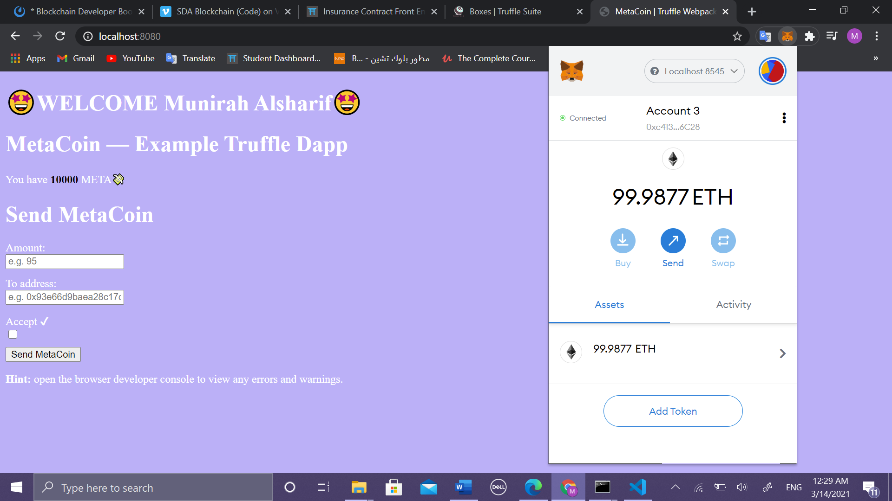

Figure 8/ this is final result after editing in html code 😎

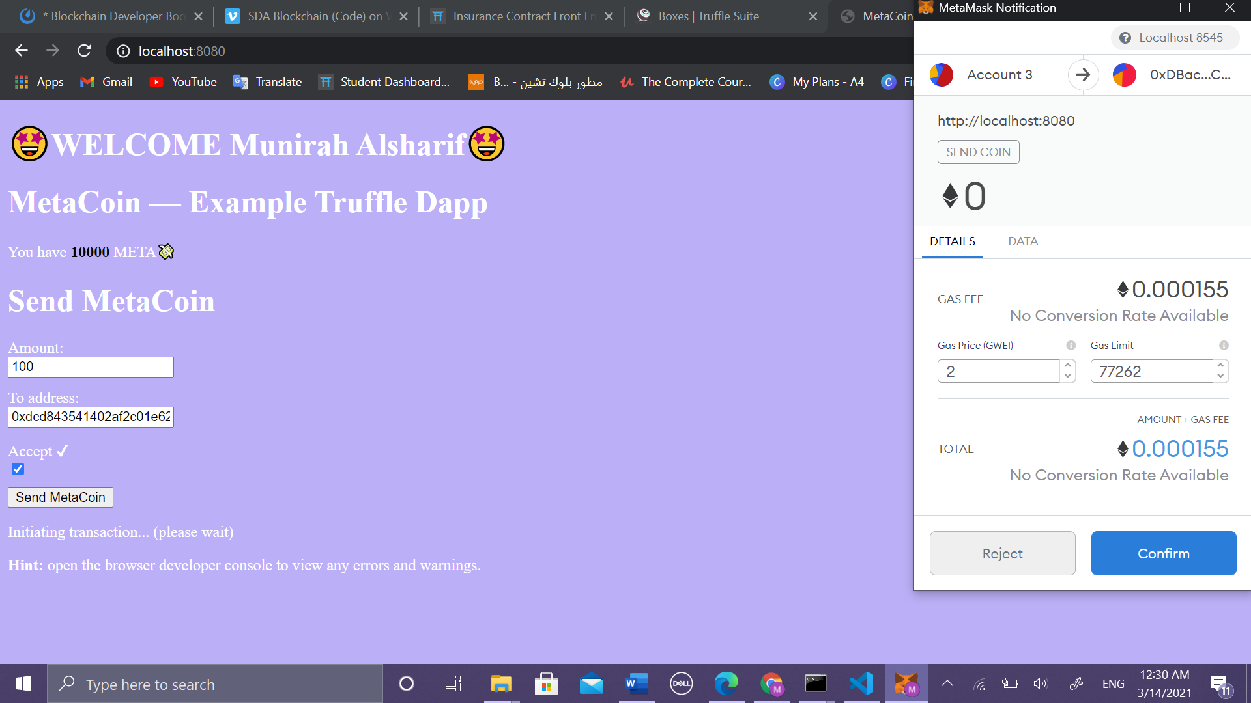

Figure 9/ try to send ✔